**Complutensian Texts (Open to Genesis 8)**

Overview Text[1]

At the turn of the 16th century, Cardinal Cardinal Francisco Jiménez de Cisneros was greatly concerned with the poor quality of Biblical scholarship in Spain, and resolved to change it through the foundation of a university at Alcalá de Henares (*Complutense* in Latin). There he gathered experts in Latin, Greek, and Hebrew – including many *conversos*, Jewish converts to Christianity – to create an edition of the Bible that included Hebrew, Latin, Greek, and Aramaic versions of Scripture on a single page. It was only in this way, Cisneros claimed in the preface to the work, that Christians could experience as much of the spiritual power and depth of the Bible as possible. Cisneros spared no expense; between acquiring manuscripts, supporting the team of scholars, creating new print types, and funding the massive effort to print the six folio volumes, the Complutensian cost an estimated 50,000 gold ducats, an immense amount. Money, however, was not the object; the first polyglot Bible was, more than anything else, an expression of religious devotion. Cisneros even stipulated in his will that a full copy of the Complutensian Bible was to be sold for no more than 6 ½ gold ducats, which guaranteed that his estate would never profit from it. Though the Bible was printed in 1517, the papacy refused to allow the editions to be sold until 1520. Of the 600 copies initially printed, only about 150 survive today.

Field Breakdowns:

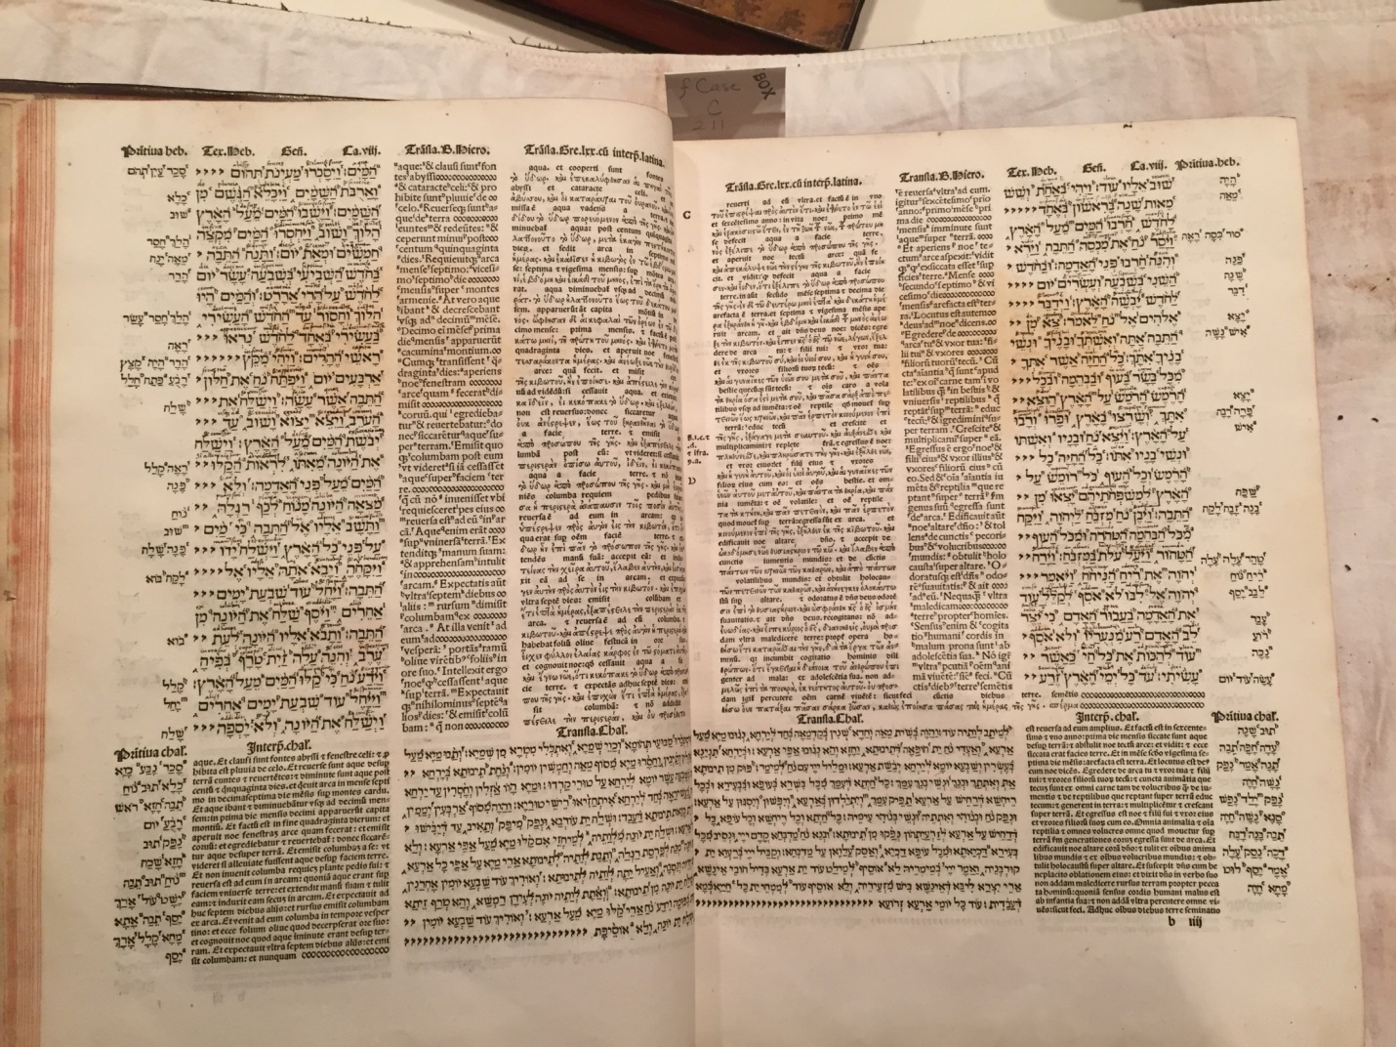

9

8

7

5

3

6

1

2

9

10

4

Window Texts:

Window Texts

1. Hebrew/Aramaic Root words
   * Category/Icon: Tools
   * Window Title: Finding Fullness of the Word
   * Subtitle: Polyglot scholars promoted understanding of Hebrew
   * Image: VAULT Case folio C 211 .51, v. 6, f. clxii – Hebrew Vocabulary in Complutensian
   * Caption Metadata (Creator, Title, Place of Creation, Creation Year)
     + Hebrew Vocabulary
     + Alcalá de Henares, Spain
     + 1517
   * Narrative
     + Hebrew, believed by many to be God’s language, was a critical component of any polyglot Bible, and features prominently in all of them. Hebrew in particular was to be the centerpiece of the Complutensian polyglot, since Cisneros believed that it contained the fullest meaning and mystery of God’s Word. Understanding Hebrew depended on understanding its root words, the building blocks on which all Hebrew vocabulary (and thus all of Scripture) were built. The Complutensian scholars hoped to promote the learning of Hebrew by including root words that were keyed to entries in the Hebrew vocabulary located in the sixth volume. By learning these words, users could better grasp the full range of meaning behind the Hebrew language, which would open the door to the deep spiritual mysteries it expressed.
   * Persistent Link to Catalog: <https://i-share.carli.illinois.edu/nby/cgi-bin/Pwebrecon.cgi?DB=local&v1=1&BBRecID=398508>
   * Other Sources:
     + Otero, Andrés Piquer and Pablo Torijano Morales, eds. *The Text of the Hebrew Bible and Its Editions: Studies in Celebration of the Fifth Centennial of the Complutensian Polyglot*. Supplements to the Textual History of the Bible 1. Leiden: Brill, 2014.
2. Hebrew Text
   * Category/Icon: Sources
   * Window Title: Making the Hebrew Text
   * Subtitle: Scholars use medieval manuscripts to create the Hebrew text
   * Image: VAULT folio Bonaparte 5022 no. 9 binding 1
   * Caption Metadata
     + First Chronicles in Hebrew
     + Spain
     + 11th century
   * Narrative
     + All polyglot texts were ultimately based on manuscript copies of biblical texts. Thanks to its thriving Jewish community, Spain was the leading center of Hebrew scholarship since the Middle Ages. Everyone agreed that the highest quality Hebrew manuscripts were produced there, so Cisneros was well-positiond to acquire the best proof texts on which to base the Complutensian’s Hebrew edition, and the *conversos* recruited to produce it – Pablo Coronel, Alfonso de Toledo, and Alfonso de Zamora – all had extensive experience working with these manuscript sources. Even the later polyglots turned to Spanish manuscripts to produce their versions. The manuscript displayed above is the Newberry’s oldest Hebrew manuscript, a fragment of the Book of Chronicles that was made in Spain at some point in the 11th century.
   * Persistent Link to Catalog : <https://i-share.carli.illinois.edu/nby/cgi-bin/Pwebrecon.cgi?DB=local&v1=1&BBRecID=961738>
   * Other Sources:
     + Ortega-Monasterio, Teresa. “Spanish Biblical Hebrew Manuscripts.” *Hebrew Studies* 45 (2004), 163-74.
3. Vulgate
   * Category/Icon: Sources
   * Window Title: The Vulgate
   * Subtitle: The standard Latin translation of the Bible poses a challenge to polyglot scholars
   * Image: Case MS 216 folio 005v
   * Caption Metadata
     + [Bible][Manuscript]
     + France(?)
     + Ca. 1230-1250
   * Narrative
     + Throughout the Middle Ages, the dominant version of the Bible was the Latin translation made in the 4th century that was attributed to St. Jerome. By the 16th century, scholars agreed that it was a very problematic text, filled with questionable translations and 1,000 years of inherited scribal errors that scholars were eager to fix. The Roman Church, however, considereed the Vulgate the definitive translation, and forbade anyone from making a corrected edition. As a result, the Complutensian scholars built their edition of the Vulgate from medieval manuscripts in Spain, none of which were complete. The Vulgate shown here a complete version of a 13th-century manuscript of the Vulgate from France.[2]
   * Persistent Link to Catalog: <https://i-share.carli.illinois.edu/nby/cgi-bin/Pwebrecon.cgi?DB=local&v1=1&BBRecID=814053>
   * Other Sources:
     + [Evangelistary] [manuscript]. Germany, between 1050 and 1100. VAULT folio Case MS 4
4. Targum Text
   * Category/Icon: Sources
   * Window Title: Aramaic
   * Subtitle: Polyglot scholars present the first translation of the Bible
   * Image: VAULT Hebrew MS 1, folio 6r-5r
   * Caption Metadata
     + Targum Onkelos of the Pentateuch
     + Italy
     + 14th century
   * Narrative
     + To represent as much of the divine mystery as possible, the Complutensian scholars decided to include the Targum, a paraphrase of the Hebrew Scriptures in Aramaic, the language that Jews spoke after classical Hebrew died out as a spoken vernacular. Manuscripts of it – such as this example from the Newberry’s collections – were widely used in Jewish synagogues throughout Europe to explain and interpret the Hebrew text. The Targum was both a translation and an explanation, incorporating commentary from generations of rabbis and even some Talmudic fables along with the text. This made it somewhat difficult to use as a source for a definitive text of the Bible, and the Complutensian only included the Targum for the first volume of the Bible (which contained the Pentateuch). Later polyglots would include the entire Targum, after more editorial work had been done.
   * Persistent Link to Catalog: <https://i-share.carli.illinois.edu/nby/cgi-bin/Pwebrecon.cgi?DB=local&v1=1&BBRecID=124482>
   * Other Sources:
     + Münster, Sebastian. *ʻArukh : dictionarium chaldaicum non ta[m] ad chaldaicos interpretes q[uam] rabbinoru[m] intelligenda co[m]mentaria necessarium*. Basel, 1527. VAULT Case PJ4937 .M86 1527
5. Septuagint Text (Greek)
   * Category: Sources
   * Window Title: The Septuagint
   * Subtitle: The Greek translation of the Old Testament gains new life in the polyglots
   * Image: Folio Inc. 5966, f. something
   * Caption Metadata
     + [Psalterium Graeco-Latinum cum canticis].
     + Milan, Italy
     + 1481
   * Narrative
     + Centuries before the birth of Christ, Greek-speaking Jews living in Egypt created a Greek translation of the Old Testament called the Septuagint, so-called because around 70 (*Septuagint* is the Latin word for 70) scholars produced it. During the Middle Ages, the Septuagint was relatively unknown in western Europe, where Jerome’s Vulgate translation dominated. Interest in learning and using Greek in religious studies grew throughout the 14th and 15th centuries, especially after the fall of Constantinople to the Ottoman Turks in 1453. Thereafter, Biblical material in Greek began to appear in print, beginning with the psalter pictured here. Inspired by this, Cisneros borrowed Septuagint manuscrips from the Vatican to produce the first printed edition of the entire Septuagint Old Testament in his polyglot.
   * Persistent Link to Catalog: <https://i-share.carli.illinois.edu/nby/cgi-bin/Pwebrecon.cgi?DB=local&v1=1&BBRecID=400646>
   * Other Sources
     + O’Connell, S. *From Most Ancient Sources: The Nature and Text-Critical Use of the Greek Old Testament Text of the Complutensian Polyglot Bible*. Fribourg/Göttingen: Vandenhoeck and Ruprecht, 2006.
6. Latin Translation of Septuagint Text
   * Category: Translations
   * Window Title: Learning Greek
   * Subtitle: Polyglots bring Greek into conversation with Hebrew for first time
   * Image: VAULT Wing ZP 538 .F92848, pp. 26-27
   * Caption Metadata
     + Sefer Tehilim = Psalterium Hebraicum.
     + Basel, Switzerland
     + 1563
   * Narrative
     + Polyglot scholars hoped that their readers would study the Bible in all the languages presented in these books, but they recognized the fact that few Europeans (even educated ones) were able to do so. Care was always taken to provide Latin translations of these other languages, so that users could see how the different languages related to each other. Demetrius Ducas, the Greek scholar tasked with preparing the Septuagint edition in the Complutensian, included a Latin translation that differed considerably from the Vulgate translation next to it. He hoped to inspire the same sort of work we see in the Hebrew Psalter pictured here, in which scholars were comfortable using Latin, Hebrew, and Greek to understand the text of the Bible.
   * Persistent Link: <https://i-share.carli.illinois.edu/nby/cgi-bin/Pwebrecon.cgi?DB=local&v1=1&BBRecID=952285>
   * Other Sources:
     + Fernández Marcos, Natalio. “Greek Sources of the Complutensian Polyglot.” *Jewish Reception of Greek Bible Versions: Studies in Their Use in Late Antiquity and the Middle Ages*. Tübingen: Siebeck, 2009, 302-315.
7. Vulgate
   * Category/Icon: Translations
   * Window Title: Calvary on the page
   * Title: Printers use page layout to protect the authority of the Vulgate
   * Image: Wing oversize ZP 5465 .P7013 from Plantin Polyglot
   * Image Caption
     + Christopher Plantin, printer
     + Antwerp, Belgium
     + 1571
   * Text: Preserving the Vulgate
     + Not everyone was excited about polyglots. Many scholars and ecclesiastical leaders argued that a polyglot edition would ruin Scripture, since it would allow the language of murderers (Jews) and heretics (Greeks) to distract readers from the essential Latin text. The Complutensian scholars refused to leave out these original languages, but placed the Vulgate in the very center of the page, with the Hebrew and Greek alongside. They described it as a representation of the Crucifixion, with Christ flanked by thieves on either side. As the image shows, the Plantin polyglot takes the same visual approach in order to appease the Catholic church. Due to its Protestant origin, the London Polyglot did not bother with this, giving more prominence to the other original languages.
   * Persistent Link: <https://i-share.carli.illinois.edu/nby/cgi-bin/Pwebrecon.cgi?DB=local&v1=1&BBRecID=234961>
   * Other Sources
     + Fernández Marcos, Natalio. “The First Polyglot Bible.” In *The Text of the Hebrew Bible and Its Editions: Studies in Celebration of the Fifth Centennial of the Complutensian Polyglot*. Supplements to the Textual History of the Bible 1. Leiden: Brill, 2014, 3-18.
8. Hebrew Text
   * Category/Icon: Sources
   * Window Title: Making Hebrew Type
   * Subtitle: Letter-founders create new typefaces for polyglots
   * Image: Case Wing Z 40535 .156, sig. B
   * Caption Metadata
     + Congregation for the Propagation of the Faith
     + Alphabeta varia
     + Rome, Italy
     + 1630
   * Narrative: Making Typefaces
     + Many of the languages that appear in polyglots had rarely, if ever, been printed before. This forced early polyglot scholars to find printers skilled enough to make new print types from scratch, often using manuscript sources. Arnao Gúillen de Brocar, the printer of the Complutensian polyglot, developed six new type founts for the work using the manuscripts Cisneros had collected. A century later, the Catholic church sought to make it easier to print in these languages by circulating print specimens taken from particular sources, such as the one pictured here, which printers throughout Europe could use to make their own types.
   * Persistent Link to Catalog: <https://i-share.carli.illinois.edu/nby/cgi-bin/Pwebrecon.cgi?DB=local&v1=1&BBRecID=286133>
   * Other Sources:
     + Hall, Basil. *The Great Polyglot Bibles*. Publication number 124 of the Book Club of California. San Francisco: Published for its members by the Book Club of California, 1966.
9. MS Annotations on Hebrew
   * Category: Tools
   * Window Title: Learning God’s Language
   * Subtitle: Polyglots make widespread study of Hebrew more available
   * Image: VAULT Wing folio ZP 538 .F9284, p. SOMETHING
   * Caption Metadata:
     + Johann Forster
     + Dictionarium Hebraicum nouum
     + Basel, Switzerland
     + 1557
   * Narrative
     + By making available definitive texts of the Bible in its original languages, polyglot scholars hoped to inspire other intelletuals to learn to use these languages on their own, so that the quality of Christian scholarship would grow. We can see this utilitarian function in the Newberry’s copy of the Complutensian, which shows how one early user tried to learn Hebrew. To do so, this user may have made use of a Latin-Hebrew dictionary such as the one by the scholar Johann Forster, who proudly claimed that his dictionary was solely on biblical sources, which the Complutensian provided in abundance.
   * Persistent Link to Catalog: <https://i-share.carli.illinois.edu/nby/cgi-bin/Pwebrecon.cgi?DB=local&v1=1&BBRecID=182836>
   * Other Sources:
     + Bell, Dean Phillip. *Jews in the Early Modern World*. New York: Rowman & Littlefield, 2008, 227-230.
10. Hebrew/Targum Root Words
    * Category/Icon: Tools
    * Window Title: Interpretive Editions
    * Subtitle: Polyglot editors interpret Hebrew before printing it
    * Image: Wing ZP 539 G 94 sig b2r b1v
    * Caption Metadata
      + Rabbi David Kimhi
      + Liber Michlol
      + Paris
      + 1540
    * Text: Translating, not transliterating
      + Classical Hebrew is composed of only consonants in its written form; readers could decide which vowels to supply when reading it, which could dramatically alter the meaning of the word. This forced editors to make decisions about how certain words could be interpreted, especially when they were compared with the Latin or Greek versions. Scholars did this by relying on Hebrew grammars, which offered guidance on how particular words ought to be pronounced. The Complutensian scholars relied especially on the work of Rabbi David Kimhi, an influential medieval grammarian whose work remained popular in the early modern period, as evidenced by the printed example shown here.
    * Persistent Link to Catalog: <https://i-share.carli.illinois.edu/nby/cgi-bin/Pwebrecon.cgi?DB=local&v1=1&BBRecID=483893>
    * Other sources:
      + Reuchlin, Johann. *De accentibus et orthographia linguae Hebraicae*. Haguenau, 1518. VAULT Case PJ4581 .R4 1518

1. This doesn’t have to go on this page, it can go on an earlier one.
2. Consider using the Newberry’s oldest dated MS of the Vulgate instead: VAULT folio Case MS 4, <https://i-share.carli.illinois.edu/nby/cgi-bin/Pwebrecon.cgi?DB=local&v1=1&BBRecID=862333>. It’s an Evangelary, though, so not the Old Testament. What I have may be the oldest one of those that we have.